# **APM-3199 - OWASP ZAP PiaB integration and report generation**

### **Configuration of OWASP ZAP**

* Install ZAP in your AWS instance.

<https://www.owasp.org/index.php/OWASP_Zed_Attack_Proxy_Project> and

download ZAP 2.7.0L

* Select “**File**” menu and select “**Session Properties**”. Its open in session Properties Box

Go to Select Box in” Authentication” and give below details for right panel

1. Go to -> right Panel -> ” Authentication method for the context”

select in “Form-based Authentication” Options

1. After that go to “Configure Authentication method section”

* Login Form Target URL

For Ex: “ui-proxy-1-0-test.magellancloud.com/portal”

* Login Request Post Data (if any)

Please give your application Username and Password as well

Below Format

Username=yourusername&Password=your password

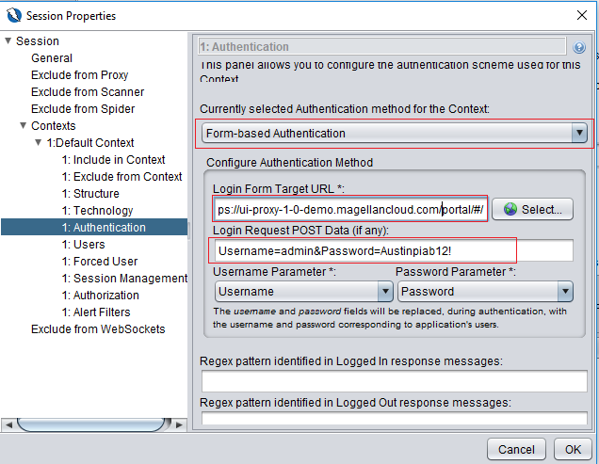

* Go to Session Properties Box in select” Users” option and click “Add” Button ->please provide your application username and password then go to click “add” button.

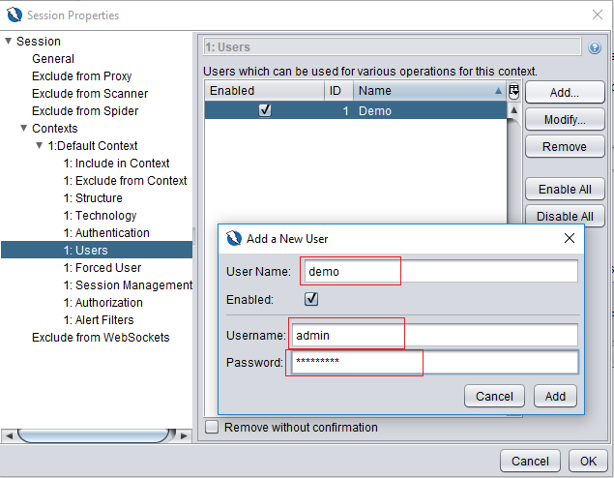

* Go to ZAP “Quick Start” select tab Session ->URL to Attack “give me your application URL” and Click the “Attack” Button. Its scanned the entire application.

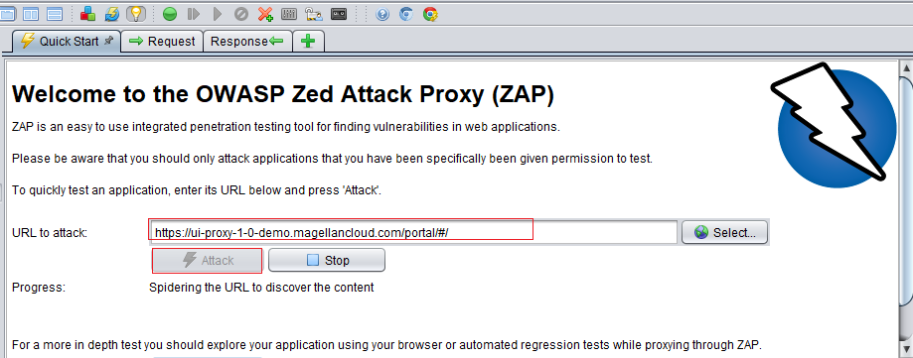

* After scan Spider and active scan have finished within 100% . Please check in your “alert” session-> Provide the Full details of our application information.

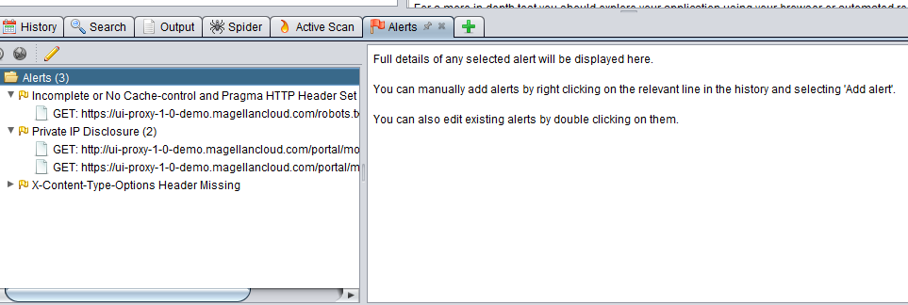

* . you go “Report” Menu click ->”Generate HTML Report”.

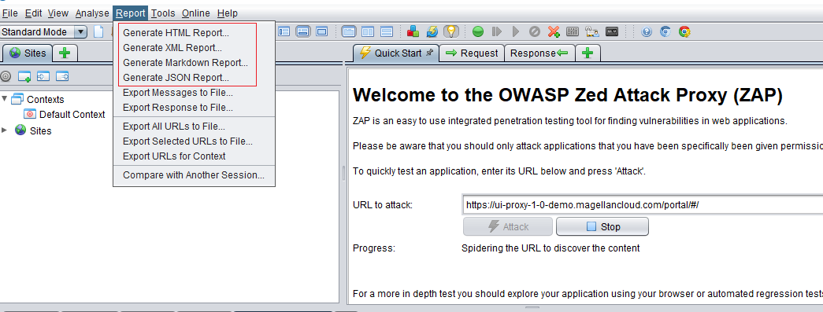

* Below the Report Summary Info in our application:

